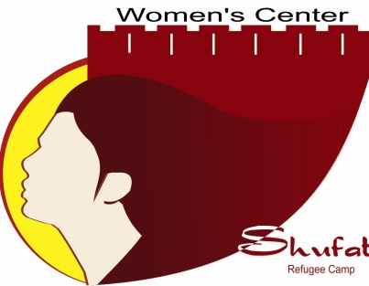

With your cooperation and support we will achieve our goals

“When Our Children and Mothers Rise, We all Rise”

About the center:

The Women’s Center (WCSHC) is an independent Palestinian NGO that was established in 1997, whose mandate is to serve and address the social, economic, cultural, and educational needs of the camp’s population of women and children.

WCSHC's mission is to empower Jerusalemite refugee and non-refugee women and children living in Shu’fat camp and the surrounding communities of Hizma and Anata.

While WCSHC is located in Shu’fat camp it is open to and employs women from Hizma and Anata. The Center is managed by an administrative committee, which elects nine members every three years. The committee supervises the planning and funding of programs and projects. A group of female personnel, appointed by the committee, supervise and implement the daily programs, projects and activities.

We believe that when Our Children and Mothers rise, we all rise.

Our Vision:

Our vision is to create a women’s forum, which provides a venue for women to assert and develop themselves, and to activate her role socially, economically and politically.

Our Mission:

WCSHC's mission is to create a safe place for women to promote social justice and change by creating societal awareness that promotes equal opportunities and reinforces the development role for Palestinian women in all areas: economic, social and political. We aim to create female leaders who will drive the social change needed to combat gender inequality.

Our Principle Goals:

•To use a rights based approach to enhance the culture of equality, and to embody the universal principles on the rights of children and women.
•To build a generation of young female social leaders who can advocate for the concerns of Jerusalem women.
•To enhance the development and training of women and children in a variety of fields, including: academic, professional, and health.
•To mobilize women to participate democratically in the decision-making process.
•To contribute to the provision of social, health, and educational and psychological support services to women, children and families.
•To promote access to education through the creation of after school classes open to women and students as well as aiding in the creation of community schools.

Woman Center Units:

- Education Unit:

- Enhancing Academic education of individual student.
- Providing technical support for education team and capacity building.
- Advocating children rights and child protection through schools and education.
- Improving children learning and communication skills, learning ability and promoting creativity.
- Planning and launching several education programs.

- Psychosocial support unit:

- Providing psychosocial support for the community.
- Raising awareness about mental health issues.
- Providing individual services for abuse.
- Managing several support groups.
- Empowering marginalized and vulnerable child and woman

- Health and Sport Unit:

- Managing several sport programs targeting child and women.
- Raising awareness of healthy living.
- Managing healthy food unit targeting local schools.

- Training and Capacity Building Unit:
- Enhancing service provide toward promoting gender and eliminating poverty.
- Developing programs targeting marginalized child and woman.

- Public Relations and Programming unit:

- Coordinate external relation and external partners.
- Setting new project, detecting local needs proposing new programming techniques.
- Launching new projects.
- Monitoring and evaluation unit.

Legal Position:

In 2004, The Women Center became registered with the Palestinian Ministry of Interior NO. (QR-216-C) as an independent, non-governmental Palestinian organization.

List of the board

Jihad Abu Zneid – | Head of the Board
I’timad Wahbeh | Deputy head of the Board
Rahaf Qawasmeh | Treasurer
Naila Mimi | Secretary
Salam Hijeh | Member
Sabreen Ghurab | Member
Sahar Mujahed | Member
Hala Al Jamal | Member
Raeda Muhasen | Member
Nawraz Salaymeh | Member
Nadera Hijawi | Member

Women's Center of Shu’fat Refugee Camp (WCSHC), Shu'fat, Jerusalem
Tel. + 972 2 5810977, Fax. +972 2 5321891, website: www.wcshc.org
E-mail: Pr_wcshc@yahoo.com

